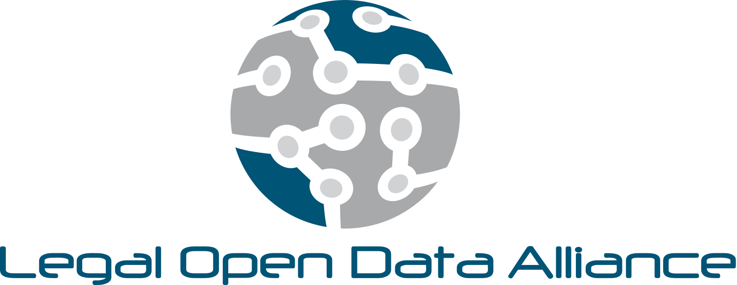

MISSION:

The Legal Open Data Alliance (LODA) is a global community of attorneys, technologists, entrepreneurs, scholars, designers, engineers, policymakers and corporate leaders, united to develop and promote sustainable standards and best practices relating to the ethical and secure collection, exchange, storage and analysis of legal data in order to better serve consumers of legal services and their attorneys.

VISION:

The global democratization of legal data through open and transparent, yet secure, methods of data transmission and analysis.

VALUES:

**Transparency & Security** — We believe in the transformative power of the open and secure flow of anonymized legal information.

**Interoperability —** We believe that a robust and dynamic ecosystem of integrated legal technology applications will form the basis of a sustainable legal data economy.

**Standardization —** We believe that the standardization of practices and norms related to open legal data sharing will accelerate and sustain advancement in legal technology and service delivery.

**Diversity** **—** We believe in the necessity of complete diversity, in people, perspectives and information sources, to manifest the best version of the world’s open legal data future.

**Ownership —** We believe that all information yielded by work done on behalf of consumers of legal services is owned by those consumers, and as such should be deployed for the benefit of those consumers.